Department of Artificial Intelligence and Data Science

**Vivekanand Education Society’s**

**Institute of Technology**

2021-2022



TIC - TAC - TOE

Submitted in partial fulfillment of the requirements of the degree of

Bachelor of Engineering in Artificial Intelligence and Data Science

by

Yash Sarang

Shreya Singh

Surabhi Tambe

Parth Suryavanshi

under the guidance of

Dr. Anjali Yeole

Department of Artificial Intelligence and Data Science

CERTIFICATE

This is to certify that Parth Suryavanshi, Yash Sarang, Surabhi Tambe, Shreya Singhin their Second Year of Artificial Intelligence and Data Science studies at the University of Mumbai have satisfactorily presented the Mini Project entitled Tic-Tac-Toe as a part of the MINI-PROJECT for Semester-III under the guidance of   
Dr. Anjali Yeole in the year 2021-2022.

Date:02/05/2022

(Name and sign) (Name and sign)

Head of Department Supervisor/Guide

DECLARATION

We, Parth Suryavanshi, Yash Sarang, Surabhi Tambe, and Shreya Singh from D6AD declare that this project represents our ideas in our own words without plagiarism and wherever others' ideas or words have been included, we have adequately cited and referenced the original sources.

We also declare that we have adhered to all principles of academic honesty and integrity and have not misrepresented or fabricated or falsified any idea/data/fact/source in our project work.

We declare that we have maintained a minimum of 75% attendance, as per the University of Mumbai norms.

We understand that any violation of the above will be cause for disciplinary action by the Institute.

Yours Faithfully,

1. Yash Sarang.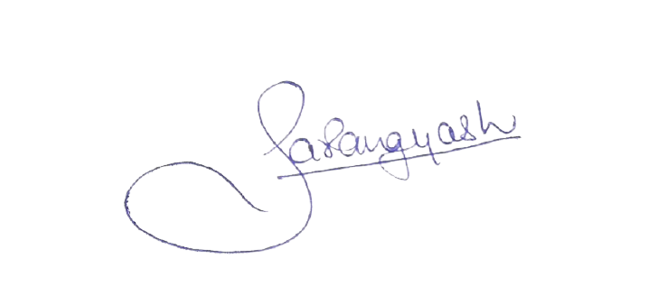
2. Parth Suryavanshi.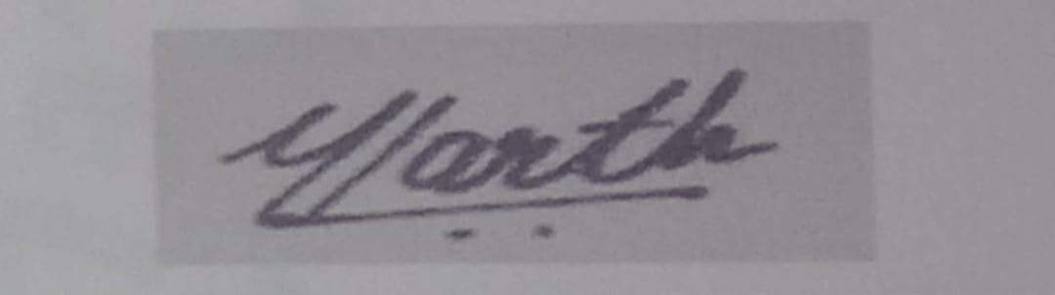
3. Surabhi Tambe.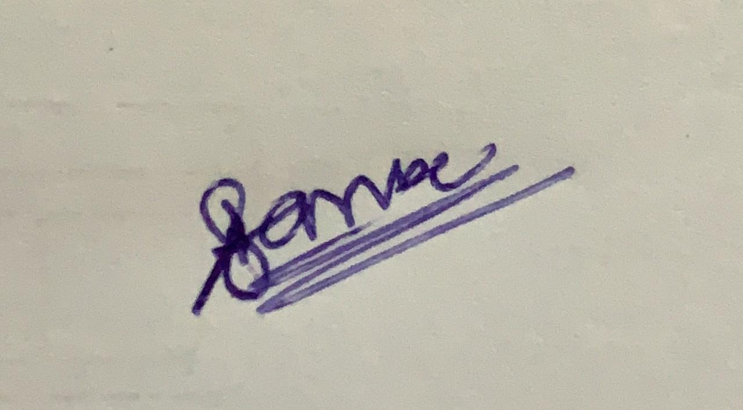
4. Shreya Singh.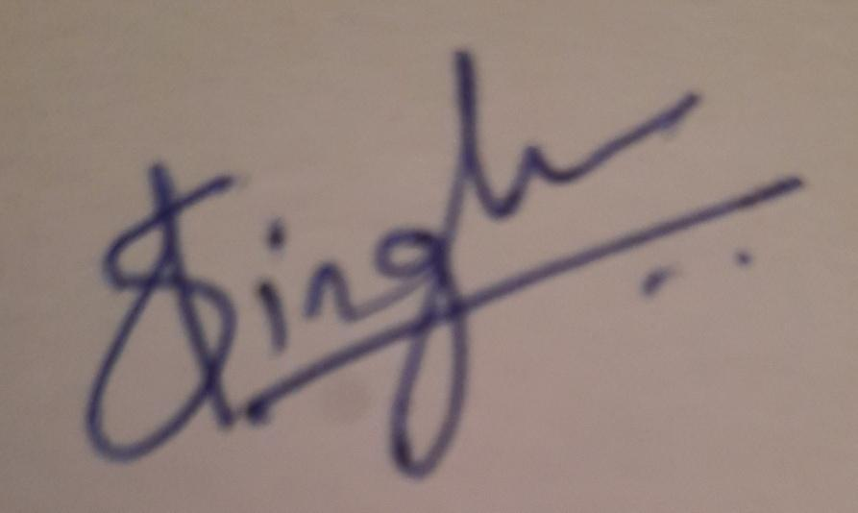 DATE: 02/05/2022

Acknowledgment

We are thankful to our college Vivekanand Education Society’s Institute of Technology for considering our project and extending help at all stages needed during our work of collecting information regarding the project.

It gives us immense pleasure to express our deep and sincere gratitude to our Guide, Dr. Anjali Yeole for her kind help and valuable advice during the development of the project synopsis and for her guidance and suggestions.

We are deeply indebted to the Vice-Principal and Head of the Artificial Intelligence and Data Science Department Dr. M. Vijayalakshmi and our Principal Dr. J.M. Nair for giving us this valuable opportunity to do this project.

We express our hearty gratitude to them for their assistance without which it would have been difficult in finishing this project synopsis and project review successfully.

We convey our deep sense of gratitude to all teaching and non-teaching staff for their constant encouragement, support, and selfless help throughout the project work. It is a great pleasure to acknowledge the help and suggestions we received from the Department of Artificial Intelligence and Data Science.

Table of Contents Pg No

* Abstract  6

1. Introduction  6

1.1 Introduction

1.2 Problem Statement

1.3 Objectives

1.4. Scope

1. Literature Survey  7

2.1 Literature/Techniques studied

2.2 Papers/Findings

1. Analysis and Design 8

3.1 Analysis of the system

3.2 Proposed Solutions

3.3 Design of the proposed system

1. Results and Discussion  10
2. Conclusion and Future Work 12

* References 13

* **Abstract**

Nowadays, every one of us, from Teachers to Students, is leading a very fast-paced life. Whether it’s conducting Viva of 60+ students or planning out our Mini Projects, we need to take breaks in between. These breaks however have to be short and refreshing so that we can get back to work with a new mindset.   
  
 The problem however is that we spend hours scrolling through social media or playing games in the name of “taking a break”. We seek to solve this problem by providing a quick and fun way to take a break using our Mini Project: Tic-Tac-Toe.

You have probably played the Tic-Tac-Toe game to pass time during school hours. It’s fun when you play with paper and pencil. Here, we have developed a **Mini Project in JavaScript called Tic-Tac-Toe game** – a web-based game with graphics that can be run through any mobile device with a valid internet connection.  
 Being true to our department, we have also implemented AI for this project.

1. Introduction

**1.1 Introduction**

Everyone is already familiar with the classic Tic-Tac-Toe. The game is very popular among all the age groups around the world. It is fairly simple by itself but the real fun begins when we exceed the bounds of the 3x3 Tic-Tac-Toe. Our Project is an upscaled version of the classic 3x3 Tic-Tac-Toe and also supports 4x4 and 5x5 grid Tic-Tac-Toe.

It is also known as **Noughts and Crosses** or the **Xs and Os**, the other names for Tic-Tac-Toe, you’ve played with paper and pencil. This mini-project game is written in JavaScript language in a very simple manner; it is complete and totally error-free.

**1.2 Problem Statement**

Build a game while implementing Artificial Intelligence into it.

**1.3 Objectives**

The main objective of this project is to create a fun and simple game of tic tac toe. There will be three versions of Tic-Tac-Toe :

* 3x3 board
* 4x4 board
* 5x5 board

**1.4 Scope**

Traditionally, the game of Tic-Tac-Toe is a pencil and paper game played by two people. Our project seeks to bring the joy of Tic-Tac-Toe in the form of a website. The best part about this is that you can play it all alone against an AI-driven bot and it’ll be compatible with both P.C. and mobile. It’s a good brain exercise for all age groups of people.

2. Literature Survey

**2.1 Literature/Techniques studied.**

* MiniMax Algorithm: We call the MiniMax function on a board position. It maps out all possible outcomes and when it reaches an endpoint, it returns a score and has it backtracked up to the original board position. If called on the maximizing player, it will choose the path with the maximum score and vice versa.
* Heuristic Search: In Tic-Tac-Toe, a possible heuristic evaluation function for the current board position is: +100 for EACH 3-in-a-line for computer. +10 for EACH two-in-a-line (with an empty cell) for the computer. +1 for EACH one-in-a-line (with two empty cells) for the computer.

**2.2 Papers/Findings**

Papers :   
International Journal of Computer Trends and   
Technology (IJCTT) - (volume 12 number 2 – Jun 2014.)*¹

The program will contain a display function and a select function to place the symbol as well as toggle between the symbols allowing each player a turn to play the game.

The program will update after each player makes their move and will check for the conditions of the game as it goes on.

Books :   
Internet & World Wide Web: How to Program Deitel, PJ Deitel.*²

3. Analysis and Design

**3.1 Analysis of the system**

**Creating the Board:**   
 For an ‘n x n’ Tic-Tac-Toe board, we make a 2-d array of dimension n x n and access the elements using nested for loops.

In case AI plays first, then it places X or O in the top left corner of the board. The future calculations are made based on this move.

The game is run using a nested for a loop until one of the 3 “End Game Conditions” occurs:

* Human wins
* AI wins
* Draw

**3.2 Proposed Solutions**

We plan on using the MiniMax algorithm and the Heuristic search method.

Heuristic search in AI is a technique to solve a problem faster than classic methods or to find an approximate solution when classic methods cannot. This is achieved by trading optimality, completeness, accuracy, or precision for speed. The heuristic search technique can evaluate the available information and decide on which branch to follow. The heuristic technique is capable of producing a solution that is good enough for the problem.

The AI will play based on the Minimax Algorithm to determine the optimum move. It is used to determine the best move possible.   
To understand the algorithm, let’s determine a “score” for a game state at any interval of time.

On winning : score = +10, On losing : score = -10. For draw : score = 0.

In Minimax the two players are called maximizer and minimizer. The maximizer tries to get the highest score possible while the minimizer tries to do the opposite and get the lowest score possible for the opponent.

Here is how the algorithm will look :

1. Create a scores list.
2. For each state of the game, add the minimax result of that state to the scores list.
3. If it's the maximizer's turn, return the maximum score from the scores list and vice  
    versa.
4. Repeat the steps until the game is over.

**3.3 Design of the proposed system**

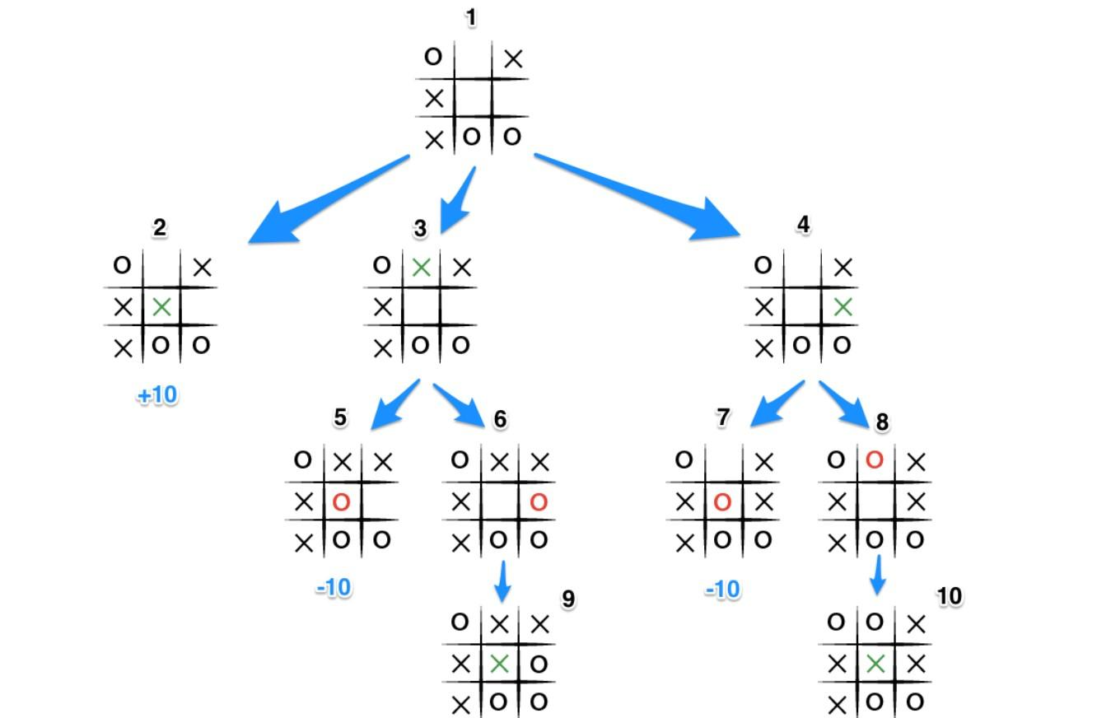

4. Results and Discussion

1. Main Screen

The main screen of our game UI would present the user to select the game type he’d like to play the game on, Single Player i.e vs an AI or Local Multiplayer.(2 players on the same device)

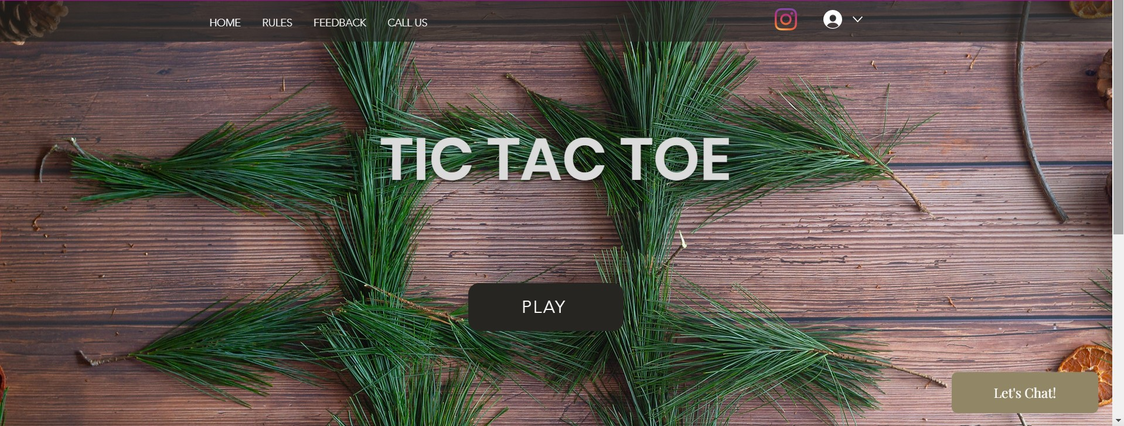

**MAIN SCREEN**

2. Selection Screen

After the selection of the main game mode, we get to select the game type.

That is whether we want to be the one who plays first (X) or we want the AI to play the first move, and also the option of choosing from 3x3 to 7x7.

We can also see a menu tab on the left-hand side of the screen which would help us to navigate efficiently at all times on our website.

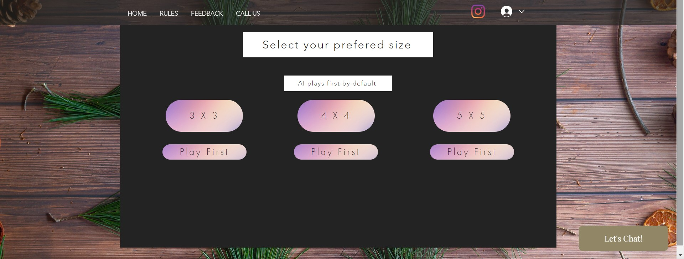

**SELECTION SCREEN**

3. Game Screen

This would be the Interactive screen on which the player would play the game.

It would display the names of the players and have the Menu tab and a cursor would appear which would point to the tile you’d be placing your turn (X or O) at.

**3x3 board**

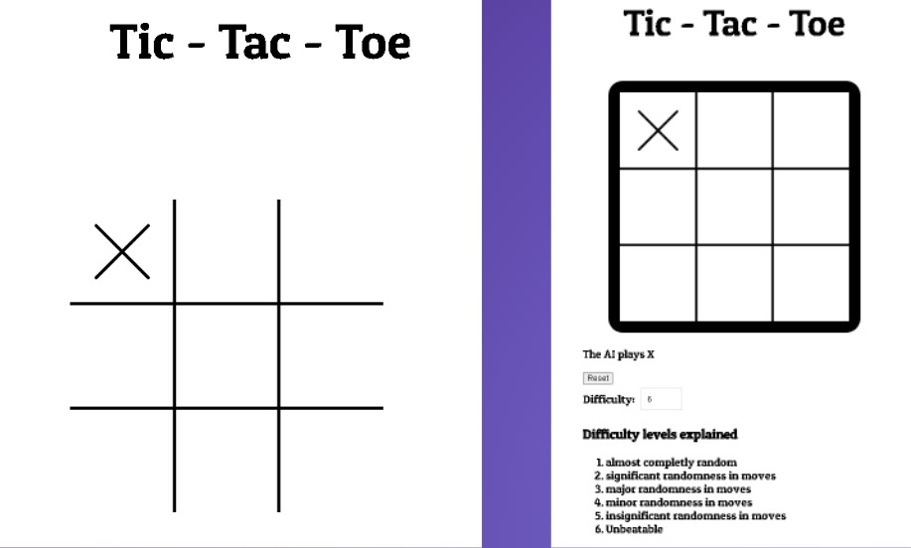

**5x5 and 4x4 board**

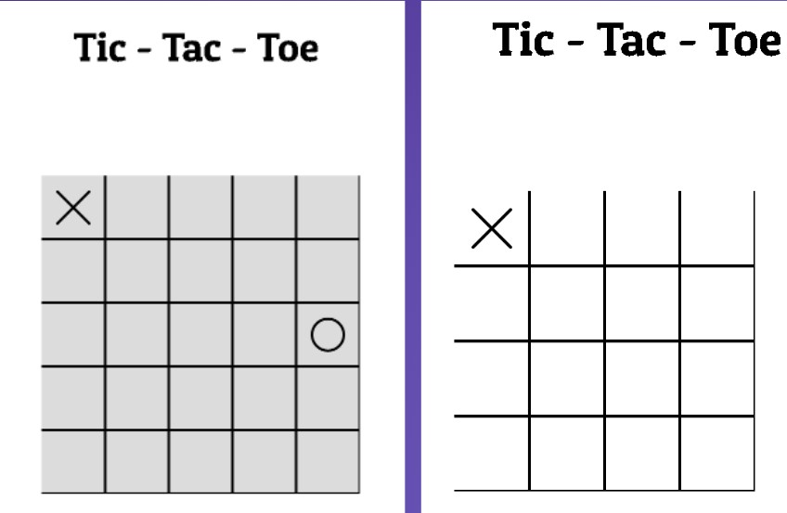

5. Conclusion and Work done in 4th Sem

1. We extended the code of 3 x 3 TicTacToe to 4 x 4 and 5 x 5. For this, we increased the size of the 2-d array and added the necessary win conditions.  
WIN CONDITIONS FOR :   
i) 3 x 3 - 3 in a row, column or diagonal.  
ii) 4 x 4 - 4 in a row, column, or diagonal.  
iii) 5 x 5 - 4 in a row, column or diagonal.

2. We created the website for our game using a cloud-based web development software called WIX.

3. We then attached the code written in JavaScript to run in the backend of the website on our localhost.

References :

International Journal of Computer Trends and Technology (IJCTT) - volume 12 number 2 – Jun 2014.

* IOP Conference Series: Materials Science and Engineering.*¹
* <https://www.neverstopbuilding.com/blog/minimax>
* Internet & World Wide Web: How to Program Deitel, PJ Deitel.*²